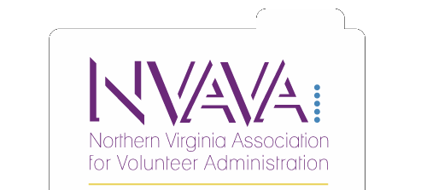

Scholarship Application 2021-2022

Name: _ Position: _

Phone: _ Email address: _

Employer: _ NVAVA Member Since: _

Scholarship Type Requested:

Training Conference Reference Materials CVA

Please complete the appropriate section and the additional questions on the following page:

Training Conference (up to $300) Amount requested:

Registration Fee | $ | Transportation | $ | Lodging | $ | Total Cost of  Conference | $

Describe the training opportunity and its relevance to volunteer management. _

How would this financial assistance help your professional development? _

Reference Materials (up to $100)

Title | Author | Cost
 |  | $
 |  | $
 |  | $
 |  | $
Total Request:

Describe the reference materials and their relevance to volunteer management. _

How would this financial assistance help your professional development? _

Angie Carrera CVA Scholarship Fund (up to $200 for certification and $100 for renewal)

Select One:

CVA Certification

CVA Renewal (Original certification date: _ )

Amount requested: $ _

Additional Questions (all applicants)

Will you be receiving additional funds to help cover expenses listed on your scholarship application from your employer or another sponsor? If yes, please explain. _

If granted a scholarship, I agree to provide proof that scholarship funds were used for the intended purpose (i.e. certificate of attendance, receipt, and proof of application) and one of the following:

[Select one]

An article for the next edition of the NVAVA newsletter

A short presentation at the next NVAVA membership workshop

I certify that all of the above information is true and correct to the best of my knowledge, and that all funds received as a result of the application will be used solely for the purpose indicated. If for any reason I am unable to participate in the above, I will return all funds awarded within one week of receipt. I understand that any deviation from the above arrangements may lead to future applications being denied. Proof of how scholarship funds were used and articles/presentations are to be received or scheduled within three months of receipt of funds.

Applicant Signature Date

NVAVA Use Only

Status | Notes
Determination
Applicant
Notified
Proof of Expenditure Received
Article/ Presentation

Reviewed by:

Resource Development Chair Date Board Member Date Board Member Date

